AUTHORIZATION AGREEMENT FOR ELECTRONIC FUNDS TRANSFERS/ACH RECURRING PAYMENTS

I (we) hereby authorize Catholic Vantage Financial Federal Credit Union, hereinafter called Credit Union, to initiate debit/credit entries to my (our) Checking and/or Savings account indicated below and the financial institution named below, hereinafter called Financial Institution, to debit same to such account. I (we) acknowledge that the origination of ACH transactions to my (our) account must comply with the provisions of U. S. law. I (we) also acknowledge that the transfers will continue until Credit Union receives instructions from any one of the account owners to stop transfers, and that such notice must be received in writing no less than ten days before next scheduled transfer.

From Bank / Credit Union Name:

Located in this city: Located in this state:

Name of Owner(s) of this Account:

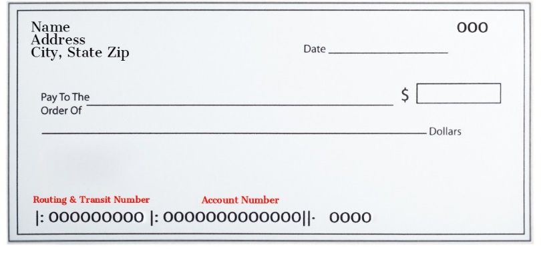
9-Digit ABA ROUTING & TRANSIT #: _____ _____ _____ _____ - _____ _____ _____ _____ - _____

ACCOUNT NUMBER: ___________________________________

Your Credit Union Loan Account Number:___________________________________________________________

Credit Union Loan ID:________ or Type of Loan___________________________ (Ex: Car Loan Make, Model, Year)

Credit Union Loan Payment Amount: $___________________ Payment Due Date:__________________________

I/WE hereby authorize recurring transfers to occur: Select one: ___ WEEKLY ___ BI-WEEKLY ____MONTHLY

To begin on _______________________________ (date) in the amount of $______________________________.

If no amount or date selected the transfer will occur monthly on the payment due date for credit union loan payment stated above.

I (we) further authorize the Credit Union to credit my (our) loan referenced above at Catholic Vantage Financial Credit Union at the same frequency and dollar amount. Under the circumstance that a payment is returned NSF, Credit Union may make one resubmission attempt at a charge of $5.00. These fees will be remitted as a separate transaction to the account authorized above. This authority is to remain in full force and effect until the Credit Union has received written notification from me (or either of us) of its termination, no later than ten business days before scheduled payment is due and in such time and in such manner as to afford the Credit Union a reasonable opportunity to act on it.

Name(s) (Please Print):____________________________________________________________________________________

Signature(s): ____________________________________________________________________________________________

Date: ______________________

FOR CREDIT UNION USE ONLY
Received By:_____________________________________________ Date Received: ________________________

